**xxx****FRONTEND DEVELOPMENT FINAL PROJECT OUTLINE**

**Amber HEART Academy - Stony Hill July 28, 2022**

**FINAL PROJECT INTRODUCTION**

The purpose of the final project is aimed at ascertaining the level of competency you have in  software development using the Angular framework and the other assistive software  development technologies that you have learned throughout the practical application of this  course. You will be required to identify a problem from within a list of categories of which you  will be provided. It is required that you design and develop the application or suite of  applications to solve the specific problem incorporating the software development tools that you  have been exposed to over the duration of the training period. **The Project is due on the 26th August. You may however request an extension of a maximum of five (5) days.**

In choosing your project ideas, you need to ensure that you pay attention to the project size and  avoid from selecting projects that would extend beyond the scope of the time frame within which  you have to complete the project.

**PROJECT CATEGORIES**

You are tasked with selecting a project from one of the following areas as your target for solving  a specific problem. While we have given examples of project ideas, you may select your own  project ideas for your work.

• Health Care: E.g. *Patient Records system that includes patients’ medical history and  doctor’s recommendations, E-Prescription application where doctors can create, update  or cancel a prescription for a patient, Doctor’s Office Appointment System etc*.

• Small Business: E.g. *Payroll software, loans software and/or website portal, Car Sales  application, Restaurant Application, Bed & Breakfast etc.*

• Security & Safety: E.g. *Security Event Logging, Incident Data Gathering & Reporting  software etc.*

• Education: E.g. *School Management System, Report Records Management, Learning  Management System, School Discussion Forum etc.*

• Religion: E.g. *Membership registration, Membership Information, Membership forum,  Tithing etc.*

**PROJECT DEADLINE & DELIVERABLES**

The project will become due on August 26th 2022. There are a number of outcomes that you  should be able to achieve in delivering your project. You are expected to submit all relevant files  pertinent to your application (*this includes the source code repository for your application*) to the  assessor(s) for examination. Documentations done outside of your source code should be done in  MS Word and submitted along with your source code. All supporting documents that span more  than one file should be zipped and properly labeled.

• **High Fidelity Graphics:** You are required to submit a high-fidelity graphic that maps to  the design you have done.

• **Technical Documentation:** You should submit a full technical documentation that  outlines all the technical details (*Also pay attention to API Endpoints explanation, major  external libraries and frameworks used, database structure and general explanation of  the functional and non-functional requirements of your application*) for the application.

• **Link to Live Application:** You should provide a link to the working application online.  If you need a domain to display your work, one will be provided to you

• **Code and Screenshots:** You should also provide a PDF file that incorporates the  screenshots for the various screens and necessary code snippets (*not all the code files,  just the major ones*) for your application. For your API screenshots, be sure to include  relevant tests using Postman. Your document should be properly formatted and the first  page should ONLY contain the information about the project and your name and date. All screenshots should be properly labelled and described.

• **Other Supporting Documents/Files:** You may submit a video with your demonstration,  but this should not replace the PDF document as that will be where your physical grade  will appear.

**AIMS AND OBJECTIVES**

**TOOLS & TECHNOLOGIES**

As our aim is to ascertain your level of skill and knowledge to apply what you have learned, we  expect that you utilize the following tools and techniques in your project.

You are expected to utilize Angular for your frontend and a suitable language that you know for  the API development. While you are not limited to Angular, you MUST have Angular code  implemented in your project. You will be tested on six (6) main areas that should demonstrate  your level of competency

**Hotel service**

**Description**

It’s a simple application that is created for the purpose of college students in mind , separating the section by gender only sharing rooms with your own gender it may also function as a normal hotel in case the target customers aren’t applying to fill rooms

**Tech**

Hotel service uses a number of open source projects to work:

* [MongoDB](https://www.mongodb.com/) - Free and open-source cross-platform document-oriented database
* [Mongoose](http://mongoosejs.com/index.html) - Elegant MongoDB object modeling for NodeJS
* [NodeJS](https://nodejs.org/en/) - Evented I/O for the backend
* [ExpressJS](https://expressjs.com/) - Fast, unopinionated, minimalist web framework for NodeJS
* [JSONWebToken](https://jwt.io/) - Used for authorization
* [Angular](https://angular.io/) - Platform that makes it easy to build applications with the web

The goal of this project is to show the core concepts of building SPA with ExpressJS and Angular. In this project I've used:

* Wrapped each major feature into a module
* Lazy-loading for most of the modules so the app can start faster
* Preload lazy-loaded modules after the app starts so they can be ready for use as soon as possible
* Shared module for compoennts, directives and pipes that can be imported into any feature module
* Services for each major feature
* Guards to prevent unauthorized users to view routes that require authentication or admin rights yet
* Interceptors for attaching JWT token to the request headers, showing notifications from the server response and error handling
* Custom directives
* Custom pipes
* TypeScript models
* Reactive forms for handling user input

**Features**

* Anonymous users
  + Login/Register
* Authenticated users
* Admin users
  + Can remove, update or delete a user

Video clip of the final project

<https://drive.google.com/file/d/1imBMQIX8DJmWGzrhdh2mcUlK6VjBqE-5/view?usp=drivesdk>

1. **API:** You are expected to create API endpoints for consumption within your application for the purpose of carrying out the CRUD functions. This indicates that your project  should comprise at least two (2) components. At least one (1) API Application (*that you  create in using Express or some other library or language*) and at least one (1) Frontend  Application (*that you create using Angular*).
2. **Login & User Management:** Your target solution should incorporate the necessary  mechanism to allow for user creation (*not solely registration*) and user validation. Ensure  that there are aspects of your application that is not restricted behind a login screen, in  other words your application should differentiate between a guest and an authenticated  user.

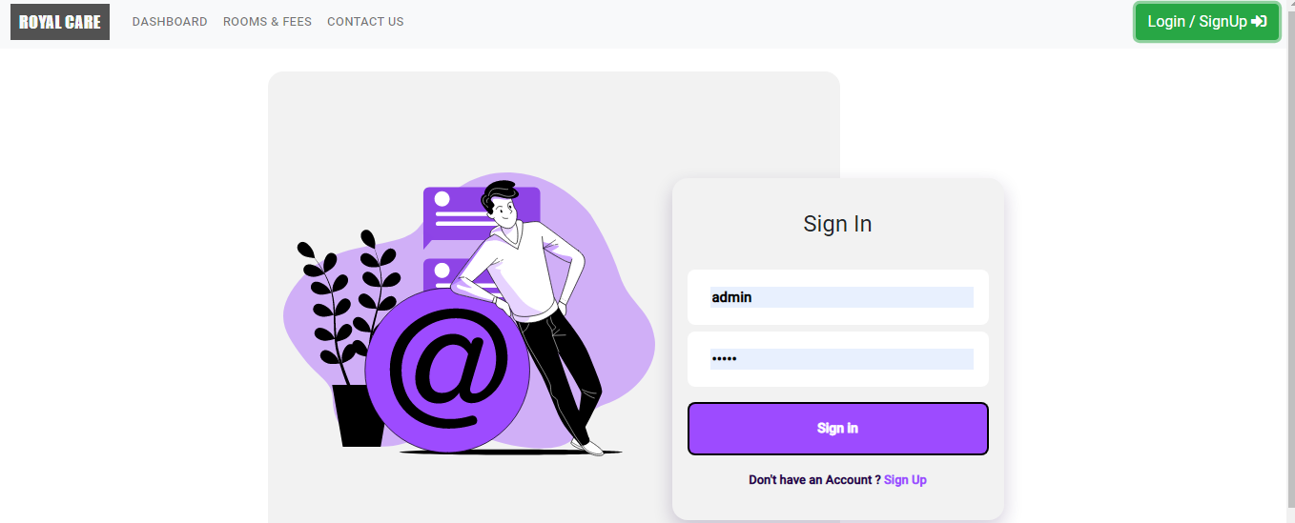

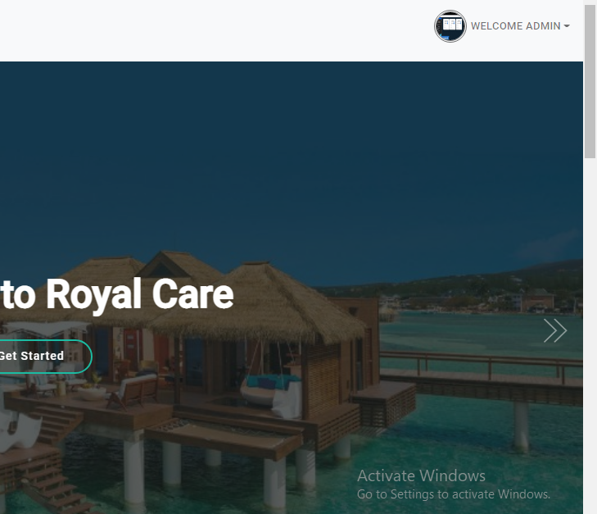

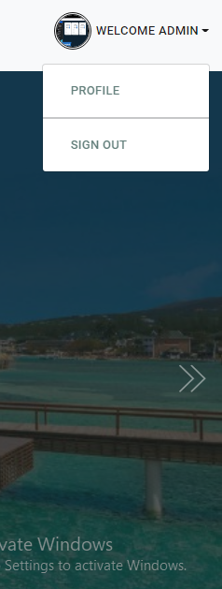

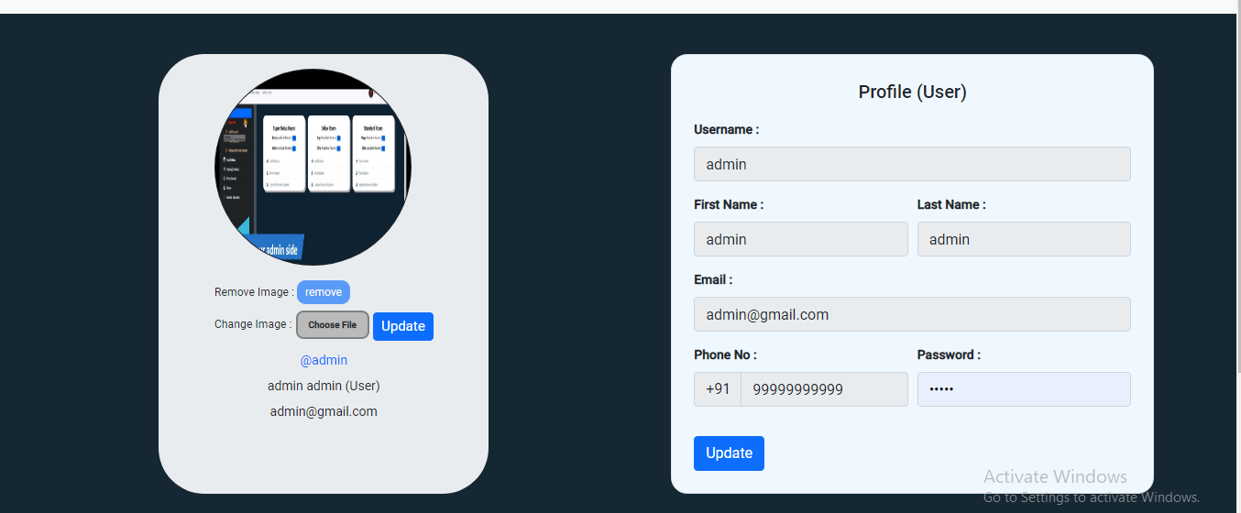

1. **Navigation:** You must ensure that a user of your application can navigate between the  various features and screens within your application seamlessly using a properly  formulated menu.

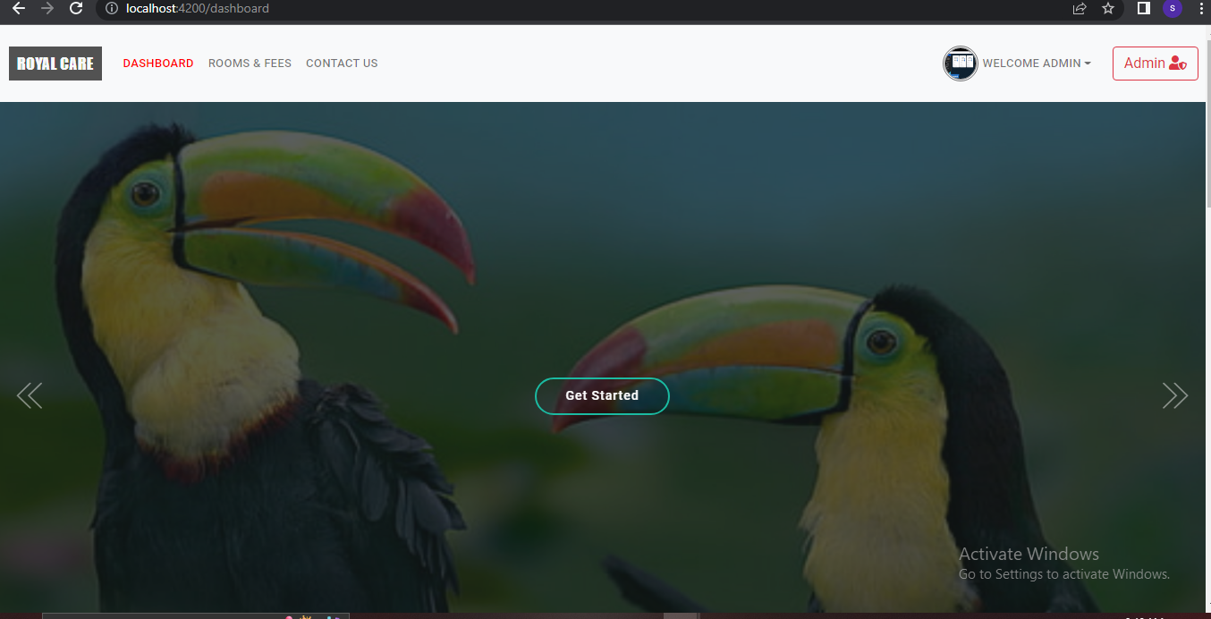

The user or admin cam easily select dashboard , room & fees , and contact us page at the top easy and simple movement between page, they can also see they profile or login in and out allin the navigation bar at the top

**4. Frontend:** Your design should be conformant with UI/UX principles to ensure an  optimal experience for your users. E.g. ***Do not provide input fields without proper  labeling, do not use check boxes for mutually exclusive options use option buttons  instead***

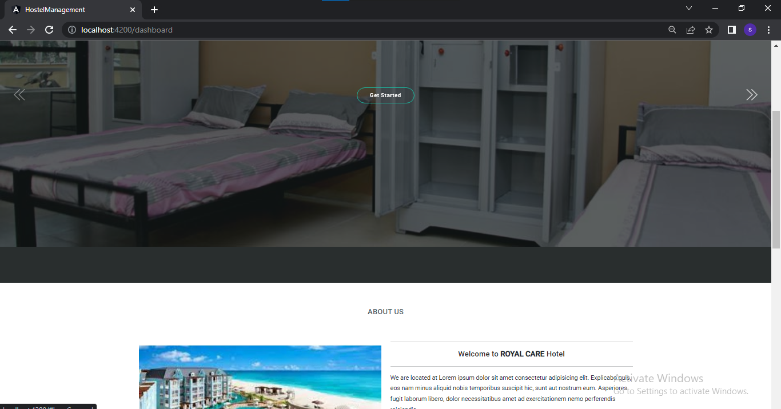

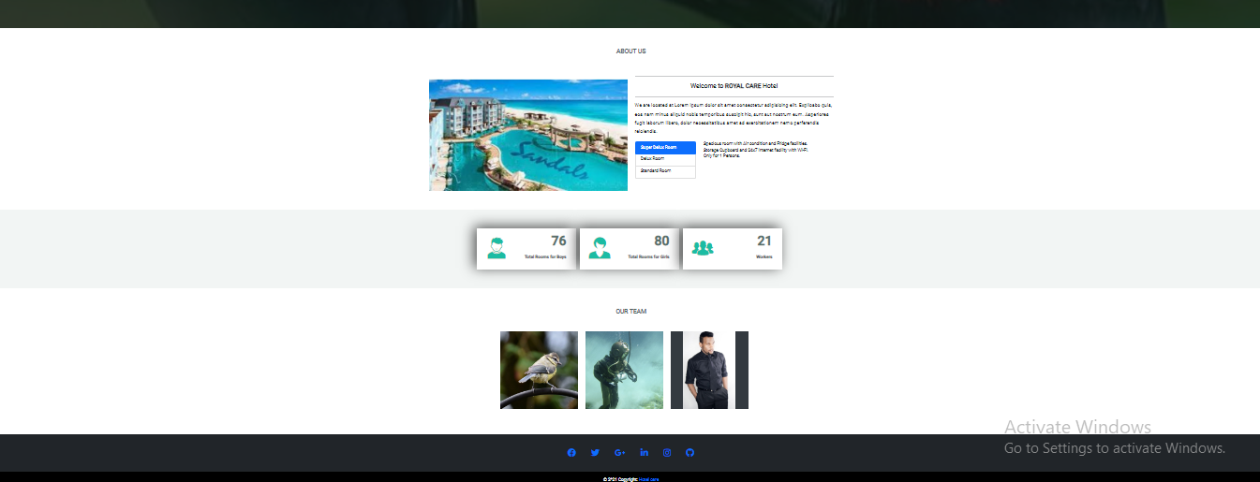

**5. Database Design:** Ensure that your database design follows the principles of Data  Normalization and is structured to achieve efficiency in data retrieval and update. **6. CRUD Functions:** Your solution should make full use of various CRUD functionalities. **a.** Data lists should be properly formatted and have the capability to allow for data  edit and delete

**MARKING SCHEME**

We will be using a Viva Criteria Marking scheme for assessing your level in all the six (6) areas that are being assessed.

|  |  |
| --- | --- |
| **MARKS** | **VIVA ASSESSMENT** |
| 5 (100) | Demonstrates skills at an excellent level. In depth knowledge and a thorough  understanding of most coding and/or the required technologies, with the  demonstrable ability to deal with advanced and complex projects. |
| 4 (80) | Demonstrates skill at optimal level. Knowledge and understanding of coding and/or  the required technologies are in some depth, demonstrable ability to deal with  intermediate projects. |
| 3 (60) | Displays adequate knowledge and understanding of most aspects of the domain and  demonstrates some ability to grasp and apply knowledge into an entry level setting  and deal with small projects. |
| 2 (40) | Outcome at beginner level. Demonstrates some superficial knowledge and  understanding of most aspects, with the ability to apply relatively simple  coding/technical skills |
| 1 (20) | Little knowledge or understanding shown. Unable to demonstrate requisite skills in a  practical setting. |

**Scorecard for: ____________________________**

**Criteria Marks Scored**

API

Login & User Management

Navigation

Frontend

Database Design

CRUD Functions

**Total**

**Remarks: _______________________________________________________________ ________________________________________________________________________**

User can create and view there profile

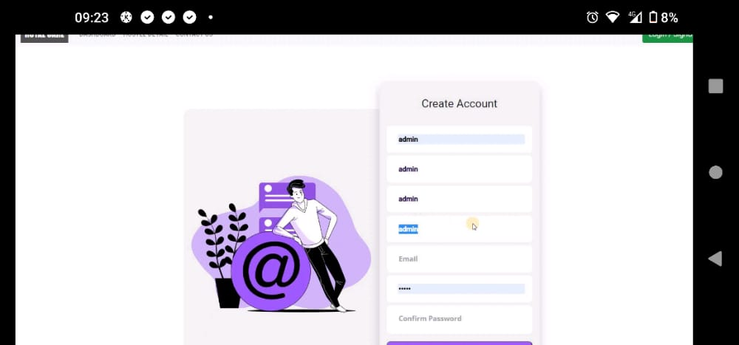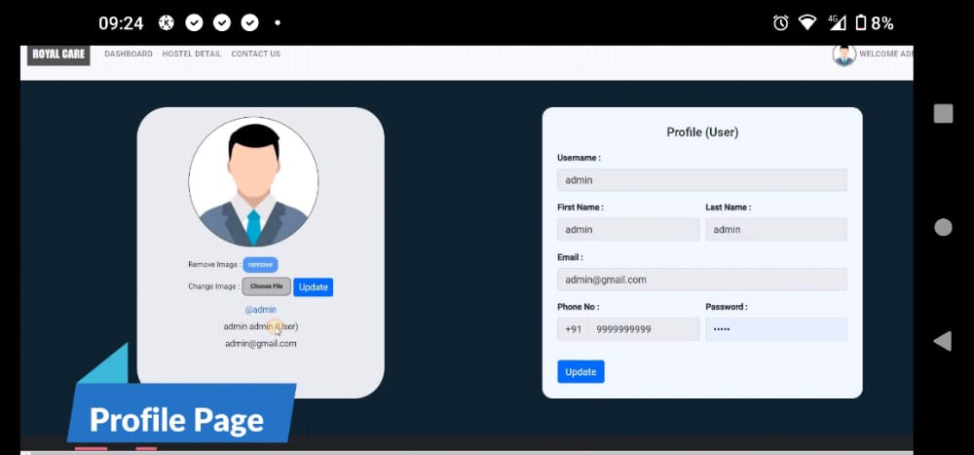

Admin view were they can remove, add, delete or update

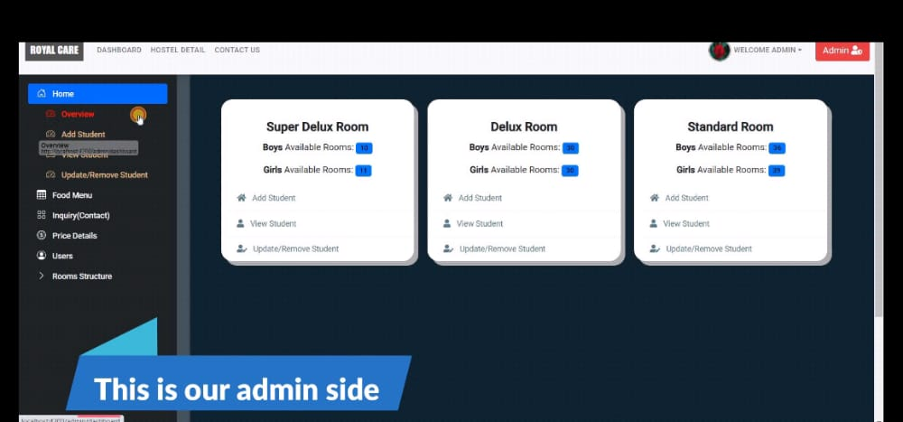

Heroko backend

Fire base frontend

Mongo db compass atlas account